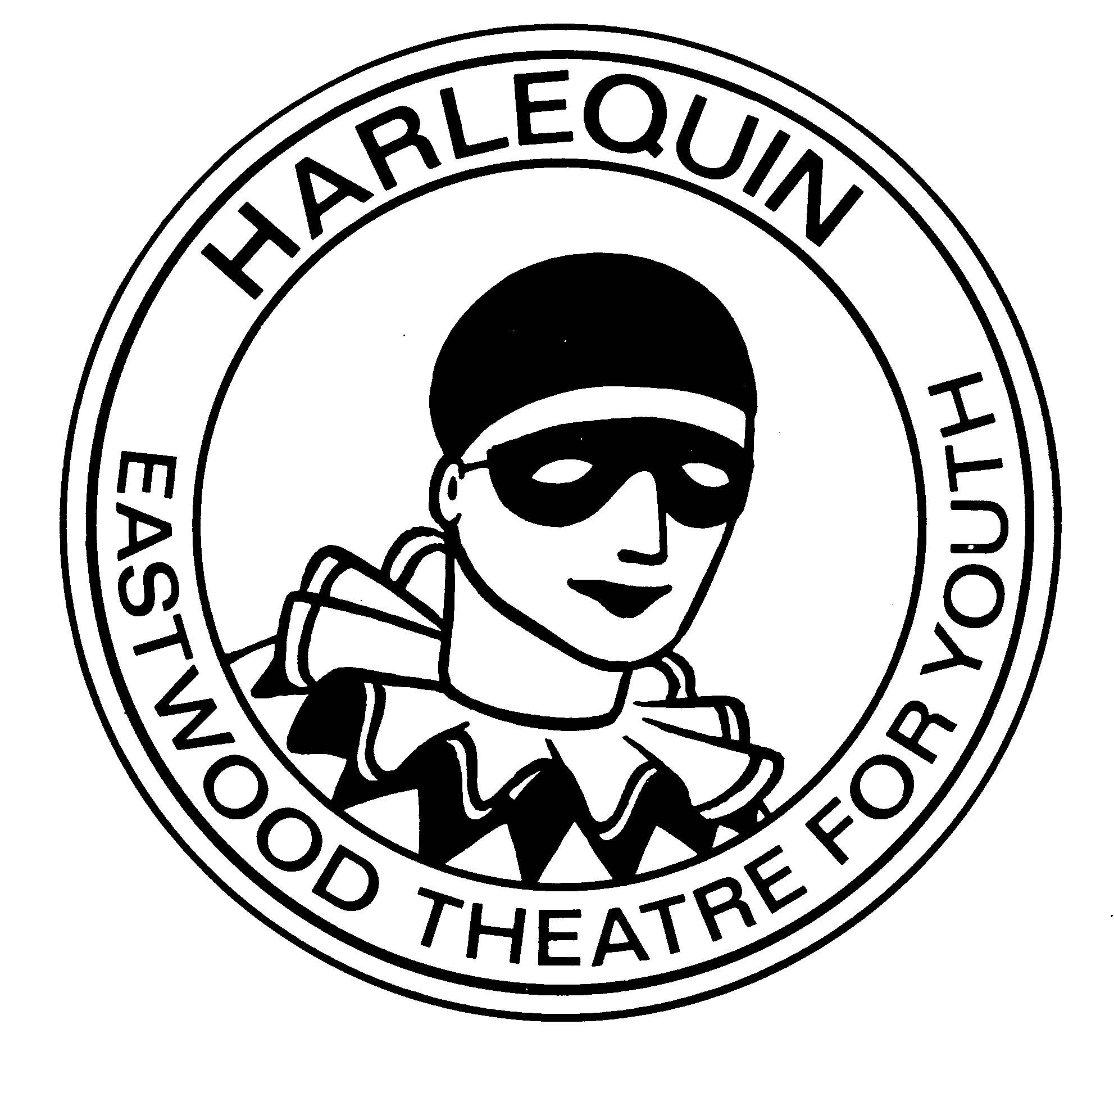 11 Lambie Crescent
Newton Mearns
Glasgow
G77 6JU
Tel: 0141 577 5996

Harlequin Senior Outing to ‘Our House-The Musical’

Dear Member

We have booked 20 tickets for the evening performance of ‘Our House’ the Madness musical for Tuesday 26 September 2017. We performed the Scottish amateur premiere of this show back in 2010 and it was a great success becoming one of our favourite shows to date. As the outing is at the Kings Theatre we would expect that you would be able to make your own arrangements for travel to and from the venue.

Tickets are £19.50 each and full payment should be made by Thursday 14th September if you wish to come along. As we have only booked 20 tickets these will be distributed on a first come first served basis.

For those age 16 years or under we would also request that you have the form below counter signed by a parent or guardian and submitted with your payment.

Committee member Hannah Muir will be collecting payments at rehearsals. Any cheques should be made payable to ‘Harlequin’. Finally, so that the club are not left out of pocket I would like to confirm that any ticket booked in your name has to be paid for. Should you be unable to attend the trip please let us know as soon as possible and we will try to assist you with reselling the ticket.

Thank-you

Ruth

OUR HOUSE Trip Tuesday 26 September 2017-Kings Theatre @ 7.30pm

NAME(Block Capitals)………………………………………………………………………………

Please can I request (Number) _____________tickets

I confirm that my son/daughter, aged under 16 is able to attend this trip.

Parent/Guardian Signature (if under 16 years)…………………………………………………

Date:……………………………………………

